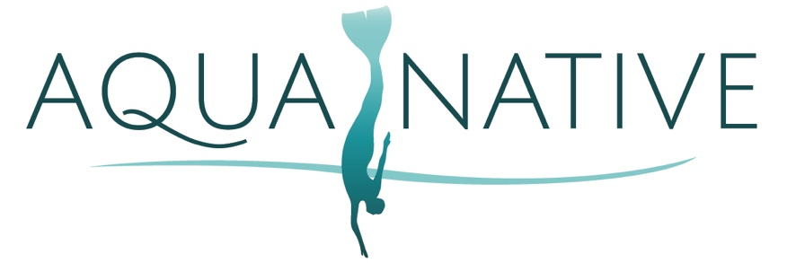

Aqua Native, LLC.
PHOTOGRAPH, FILM, VIDEO AND AUDIO CONSENT AND RELEASE

Aqua Native, LLC. (“Aqua Native”) uses images and sounds of persons Mermaid diving and participating in its programs and events. Aqua Native does not use a person’s likeness, or identify any person by name, unless it has received specific written permission to do so.

In consideration of the above, I hereby grant Aqua Native permission:
- to photograph, film, and make audio and/or video recordings of, myself, and

- to use and display the photograph(s), film(s), and audio and/or video recording(s) of me and my likeness, voice, and appearance, in whole or in part, in Dive Utah’s website, archives, and promotional and/or informational material (including, but not limited to, newsletters, brochures, advertisements, and newspaper articles), and in any and all media, broadcast, or digital format, including electronic, radio, internet, and television, throughout the world.

I hereby waive and release any right to compensation for, or ownership of, such photograph(s), film(s), and audio and/or video recording(s) of me and the above uses of them by Aqua Native.

I have read this consent and release and agree to its terms and conditions.

A parent or guardian must sign this consent and release on behalf of a child under the age of 18.

If a parent or guardian participates in a program or event with his or her child, signing on behalf of the child will also indicate that the parent or guardian also consents to the terms and conditions of this consent and release for him or herself.

Print Name

Signature

Guardian Signature

Email Address

Date

